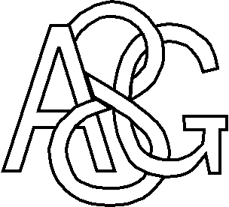
EAGCC Women’s Subscriptions and Match Fees 2023

January 2023

Dear EAGCC members

2022 was a great year for women’s cricket at the Green, with more regular success on the field and the start of a ladies’ softball team. Rachel Watson did a great job in organising post-match BBQs, annual awards and quizzes.

The men’s teams were successful too, with both Saturday XIs maintaining their places in their leagues and lots of our younger players representing Duncan’s Sunday XI.

The Committee have considered the structure of subs and match fees, which has worked well for some time now. In 2023 there will be a small increase to reflect increased running costs. The all-in subscription will go from £40 to £50.

All-in annual subscription (no match fees!)

Men’s teams - £210
Women’s teams - £50

Reduced subscription plus match fees

Men’s teams - £100 subscription plus £10 a match
Women’s team - £25 subscription plus £5 a match

Members are asked to be prompt with payment of subs, which are due by May 31st at the latest.

Payments can be made by cheque, bank transfer (preferred) or Standing Order. Please return the attached membership form to Tim Chambers to show how you will be paying (it can be printed off and filled in, or emailed).

Thank you for your support - we look forward to seeing you throughout the 2023 season.

Tim Chambers (Chairman) Dave Stovell (Treasurer)
timcorpheus@gmail.com david.stovell66@icloud.com)

PTO for membership form

EAGCC Senior Membership Form 2023 (Women)

Personal details
Name
Date of birth
Address
Email address
Home phone
Mobile phone
Emergency Contact | Name |  | Contact no.

I wish to pay my membership subscription as follows (please tick one)
All-in subscription (no match fees) | Single payment of £50
Reduced subscription (plus match fees) | £25 + £5 per match

Method of payment (please tick one)
Cheque (payable to Eight Ash Green Cricket Club)
Bank Transfer (sort code 60-24-17, acc. no. 63724154) *

* If paying online, please enter your surname as the reference

Player’s declaration
I confirm that I am aware of and agree to follow the policies published on the club website, especially those relating to the safety and welfare of children.

Signed |  | Date

Please return this form on paper or by email (along with any enclosed payment if paying by cheque) to Tim Chambers:

Tim Chambers
EAGCC Membership
56 Upland Drive
Colchester
CO4 0PZ
timcorpheus@gmail.com

